Logo
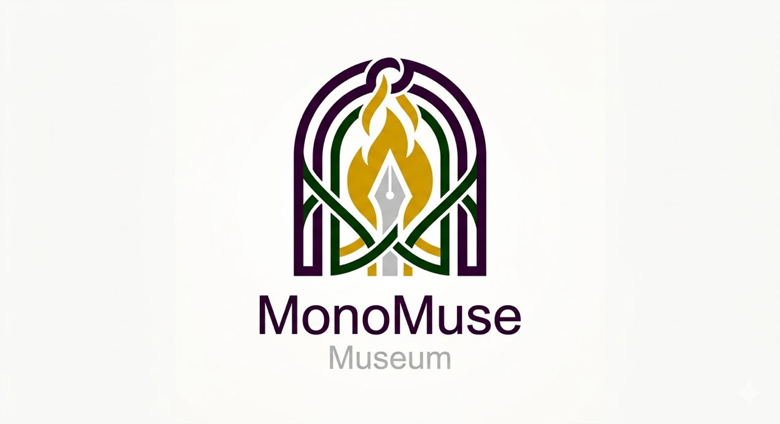
Colors
#330033 | #CC9900 | #003300 | #CCCCCC

Fonts
- Georgia
- Arial
- Trebuchet MS

Samples
- Heading 1
- Heading 2
- Heading 3
- Body Text
- Bulleted Point

